## Lab 8: Deploy Flask on Kubernetes Cluster Hosted on Digital Ocean

## Microservices and Cloud Computing - CSC 5201 301

### Hudson Arney

### 21 October 2024

**Provide a brief description of the functionality and API for your application.**

This Flask-based web application is designed to manage baseball player statistics and give them a basic visualization (could be easily changed to other sports stats). The core functionality includes creating, retrieving/selecting, updating, and deleting player(s). Users can access a list of all players, add new players through a form, update player details, or delete existing ones. Each player record includes attributes such as home runs, WAR (Wins Above Replacement), OPS+, etc. The application uses RESTful API endpoints for retrieving and modifying individual player data via HTTP methods like GET, POST, PUT, and DELETE.

P.S. Forgive me for repeating a lot of already known information in regard to the lab, I’m keeping incase I ever look back at this in a few weeks (or years haha).

**Submit a screenshot of your application running locally.**

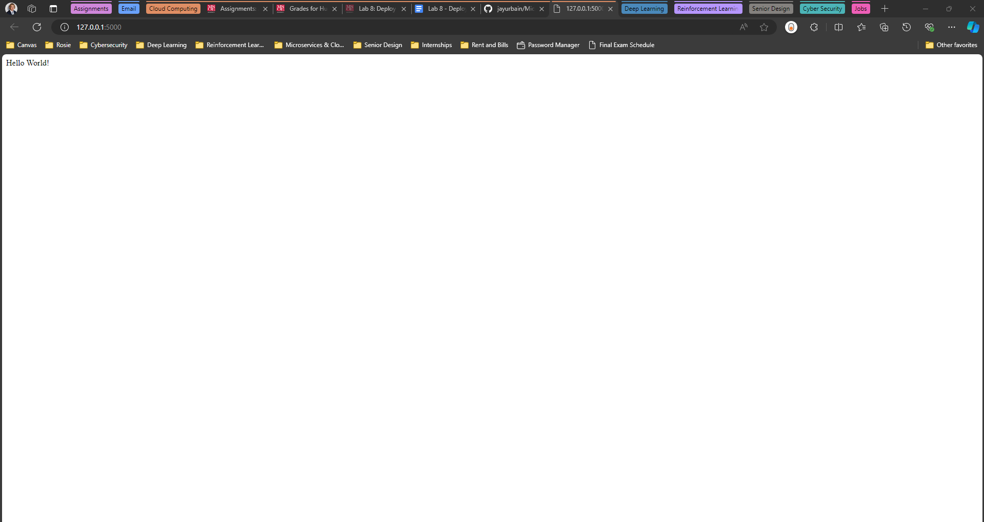

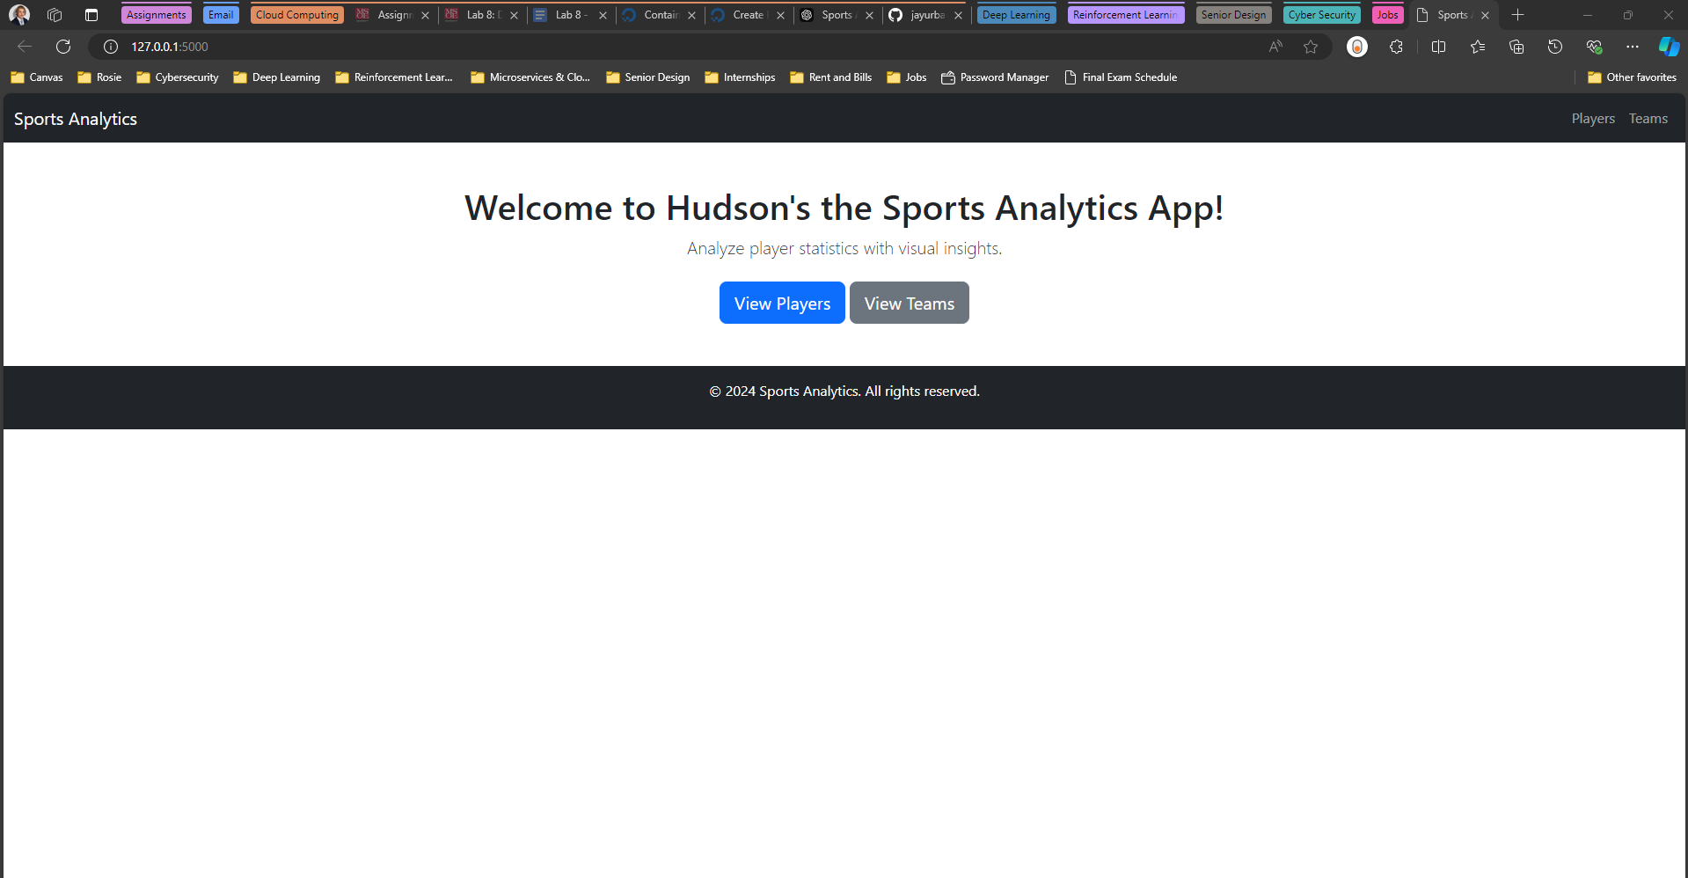

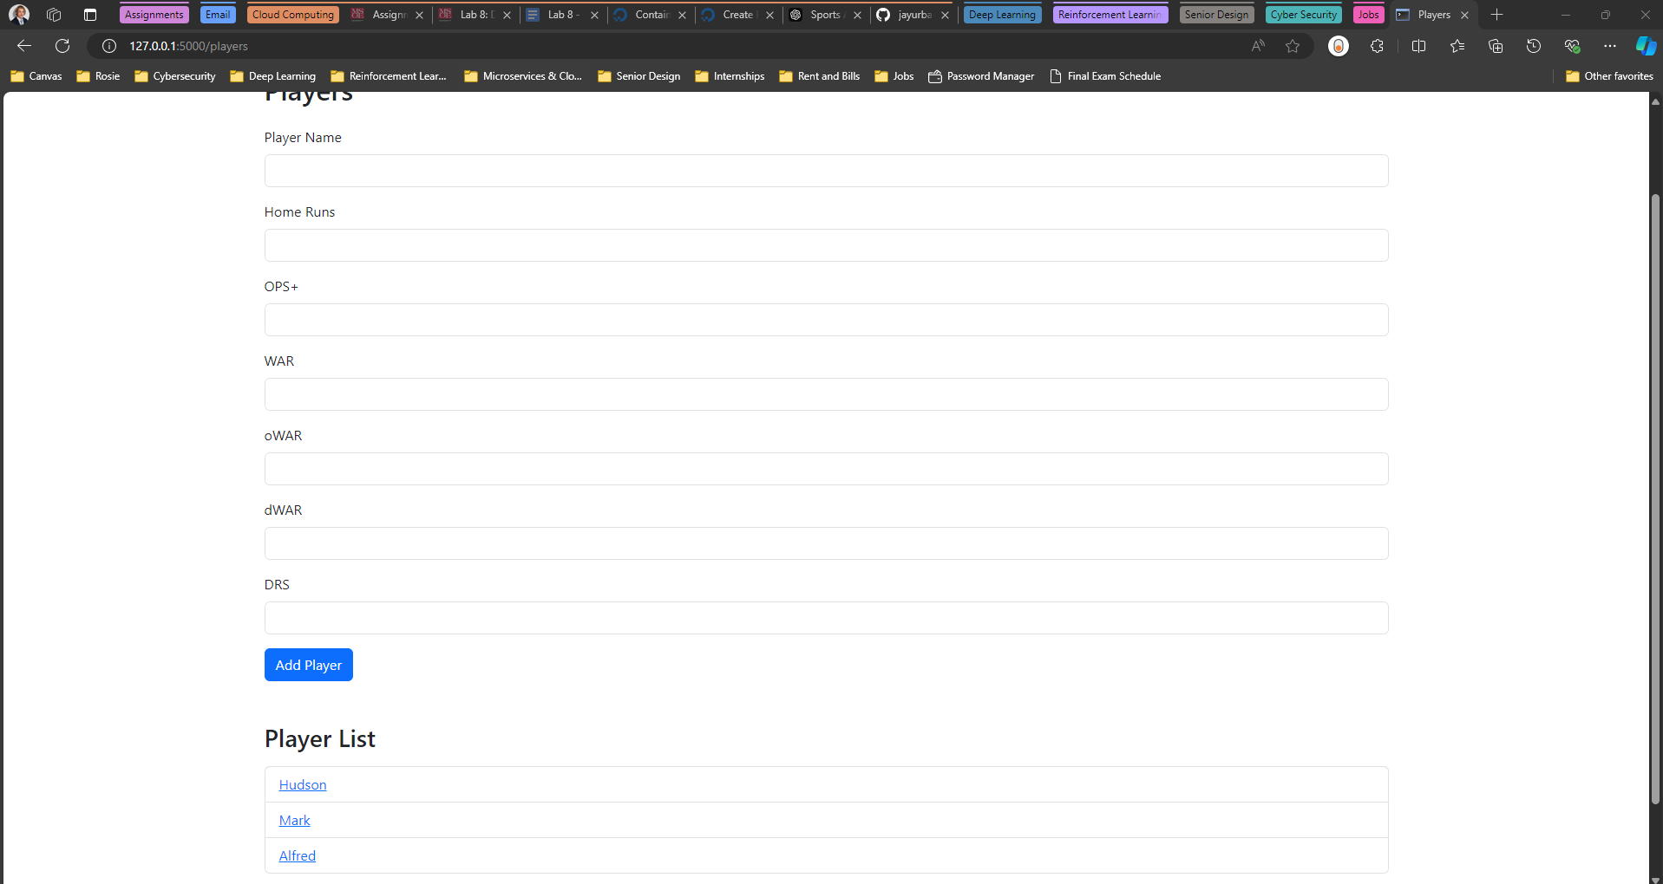

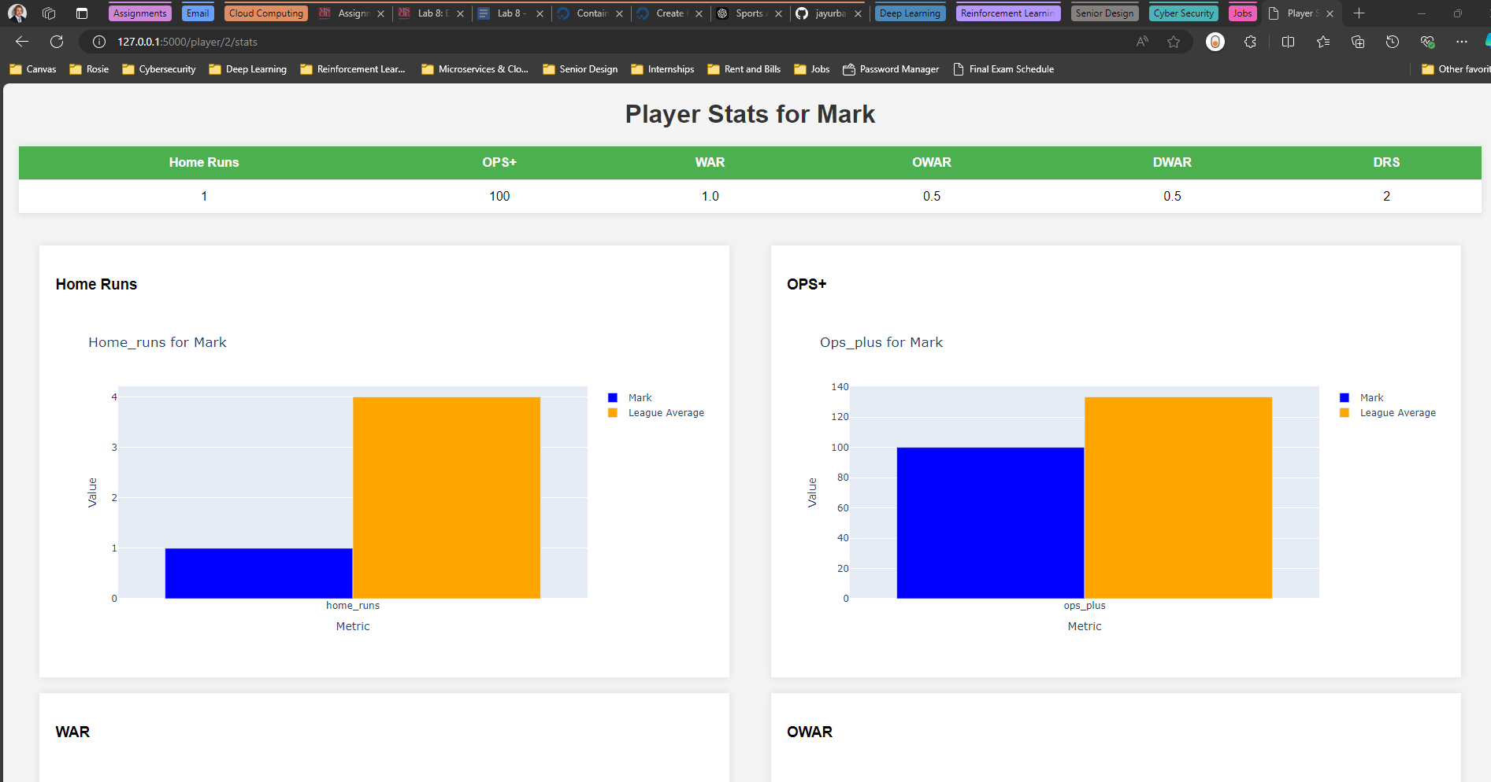

**Submit a screenshot of your DigitalOcean app running from the repository.**

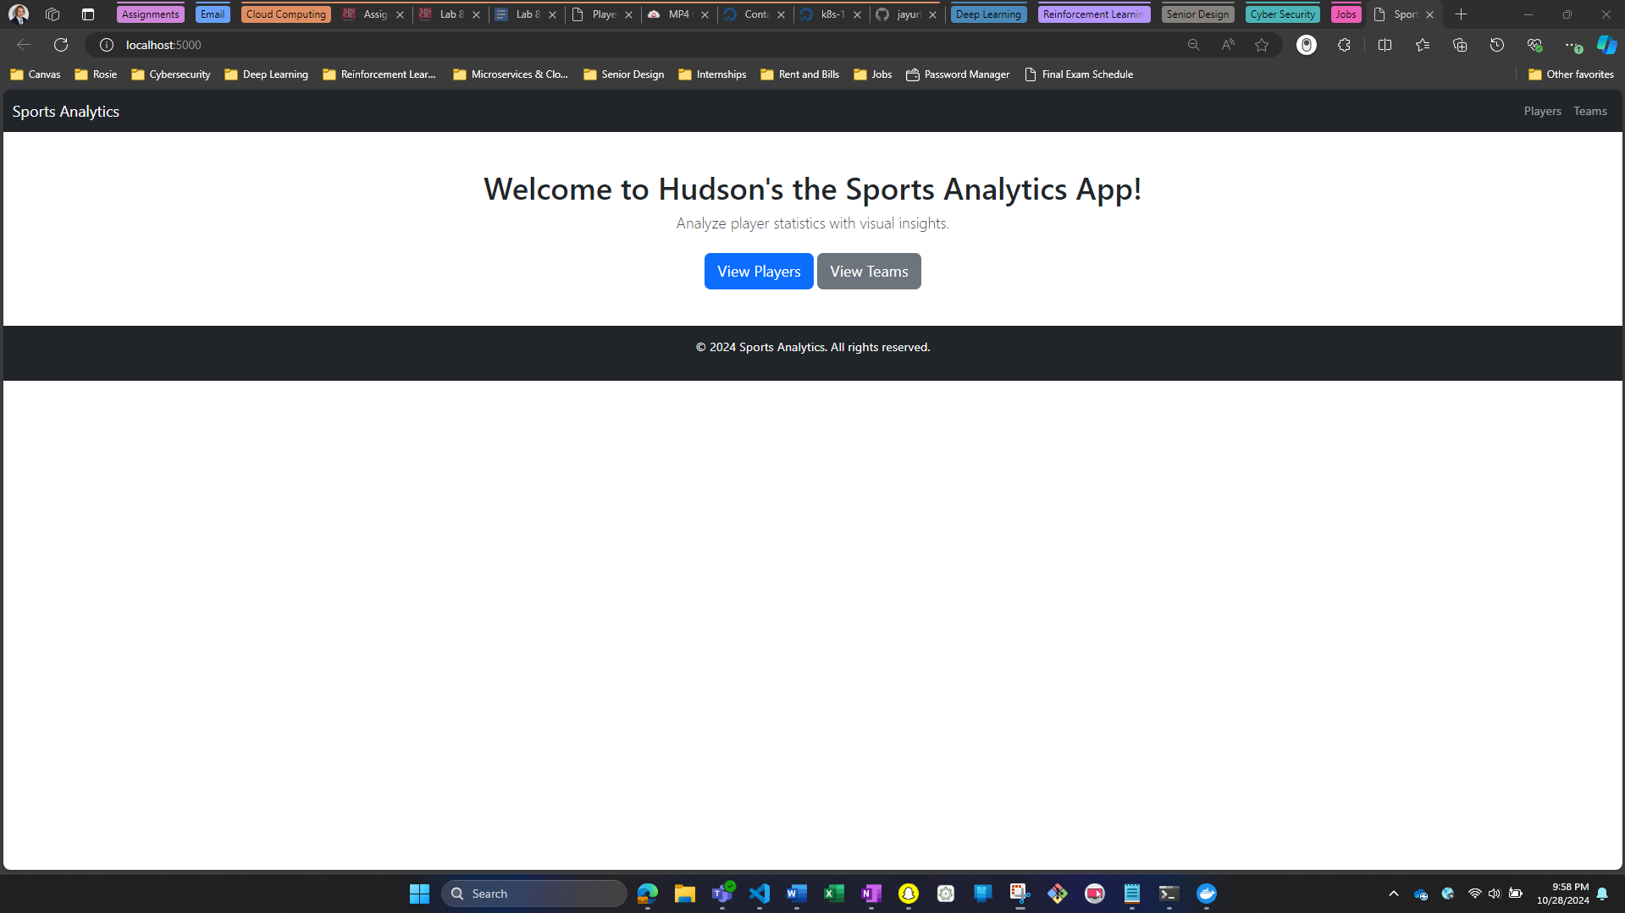

**Submit snapshots of each function with your microservices application and feedback on the lab.**



My apologies this “GIF” is 2 minutes long. I tried showing off all of the apps functionality in one video that will display in a word doc

**Submit your report along with a link to a github repository with your code.**

[**Github Repo Link - GO TO Lab 8**](https://github.com/arneyHudson/Microservices-and-Cloud-Computing/)

This has a few of the labs from this year, I decided to upload a few of the old ones at a time. Just go to the Lab 8 folder. I’m hoping this works

**Post Lab Thoughts w/ Feedback:**

Thank you again for the help! I often get stuck and having someone to talk to helps me tremendously. Also telling me the port # issue in the .yml files probably saved me a good amount of time (although I did see something like that in the top of the lab instructions).

I had fun with this lab in both designing the app and finally getting all the puzzle pieces together with digital ocean at the end. Although this app is nothing special, it was fun to create from scratch. I like when given freedom to make whatever you’d like. I also thought there were a lot of important things I learned in this lab. I can’t imagine the headache of doing all of this without the demo instructions we are given from you. As with most of these labs, there was a lot of trial and error but I eventually got it to go.